**KAREN DUNN, SENIOR ANALYST**





Karen Dunn brings over 30 years of banking experience on both the credit and sales sides of the business with an emphasis in commercial lending and credit administration. She has held positions as Commercial Lender, Senior Commercial Lender, Chief Credit Officer, Senior Management Team and Retail Bank Manager.

Karen’s banking experience includes both community banks along with a large national bank. Most recently, Karen served as the Chief Credit Officer for a $350 million-dollar bank.

Karen's responsibilities as chief credit officer included implementation and oversight of all credit policies, loan operations and loan servicing departments and managing a team of credit analysts. Karen led a team to conduct due diligence and successfully completed a bank acquisition and integration.

As a Senior Lender, Karen managed a team of professionals accountable for the growth of the bank. In addition, she was responsible for administration of the Watch List, managed classified credits, and oversaw loan workouts. She ensured that all policies and procedures for calculating the Allowance for Loan and Lease Losses were well designed and operated according to internal and industry standards.

Karen received her degree in finance from Viterbo University and has successfully completed many hours of banking related seminars and webinars.

Karen serves and has served on numerous non-profit boards including: Coulee Region Business Incubator – Past Chair; Western Wisconsin Workforce Development Board -Past Chair; University of Wisconsin La Crosse, School of Business Advisory Board; City of

La Crosse Redevelopment Authority – current board member.

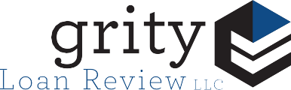

Karen@integrityloanreview.com • P: 608-386-7794 [• www.integrityloanreview.com](http://www.integrityloanreview.com/)